What I Learn from the Fashion App Project

I learn that UI/UX is very hard job to do many people miss understand the UI aspect and the Front End aspect of it. Especially when I work together with the group.

But this is Okay, at least I am in the right direction. There are many conflict what soever in the project but I am just glad we get to the decision make it and re doing what we are doing best.

What my mistake was

From my very first design I am lacking of usability

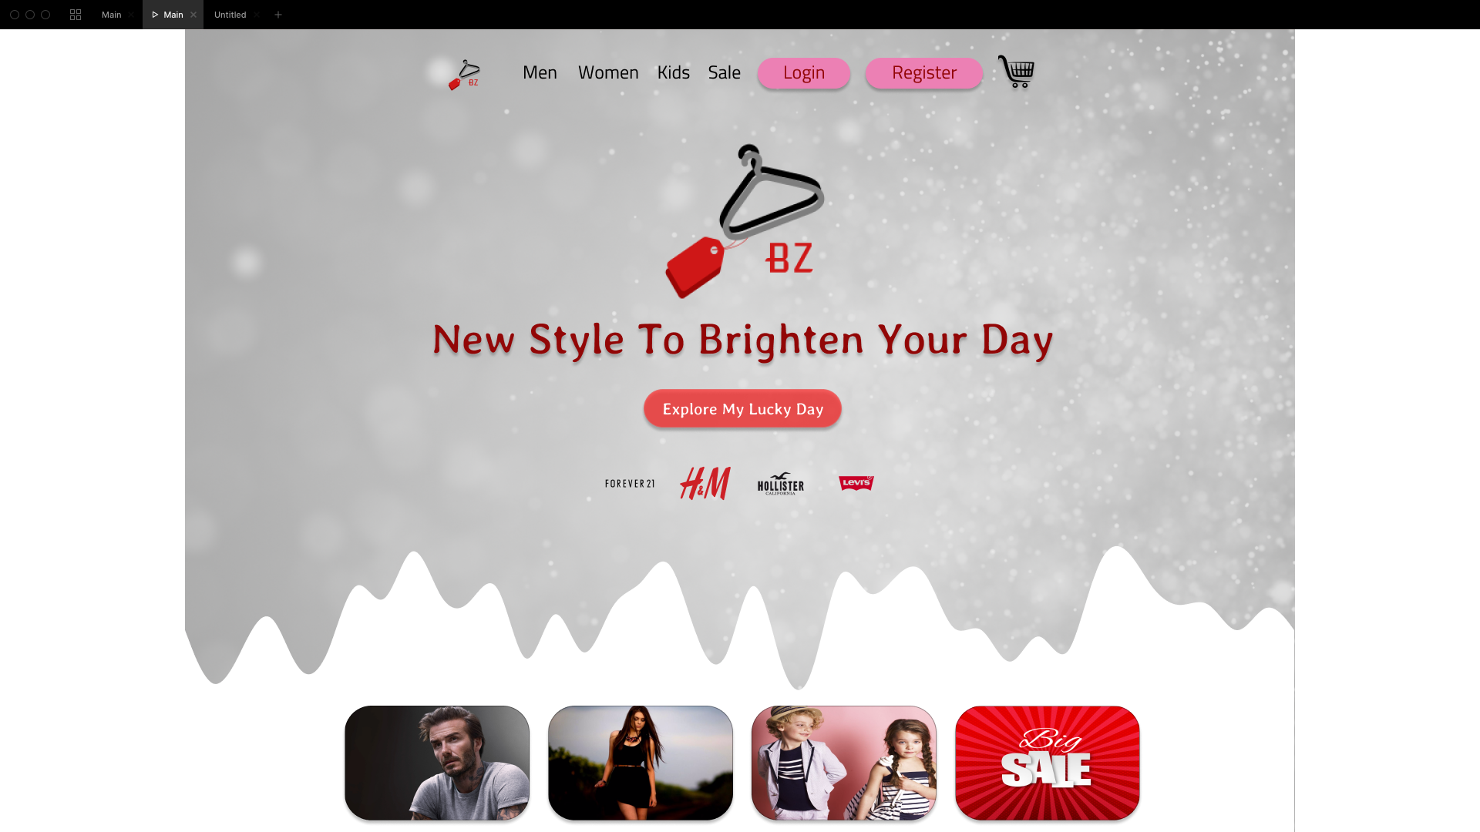

The Wave that I was thinking a cool idea is not cool at all. People get dizzy of it so i have get rid of it. Many people not having a fun time looking at my website especially the background. So I do some more research about it. Many women and men dislike the color of gray so I get rid of it completely.

Second Design

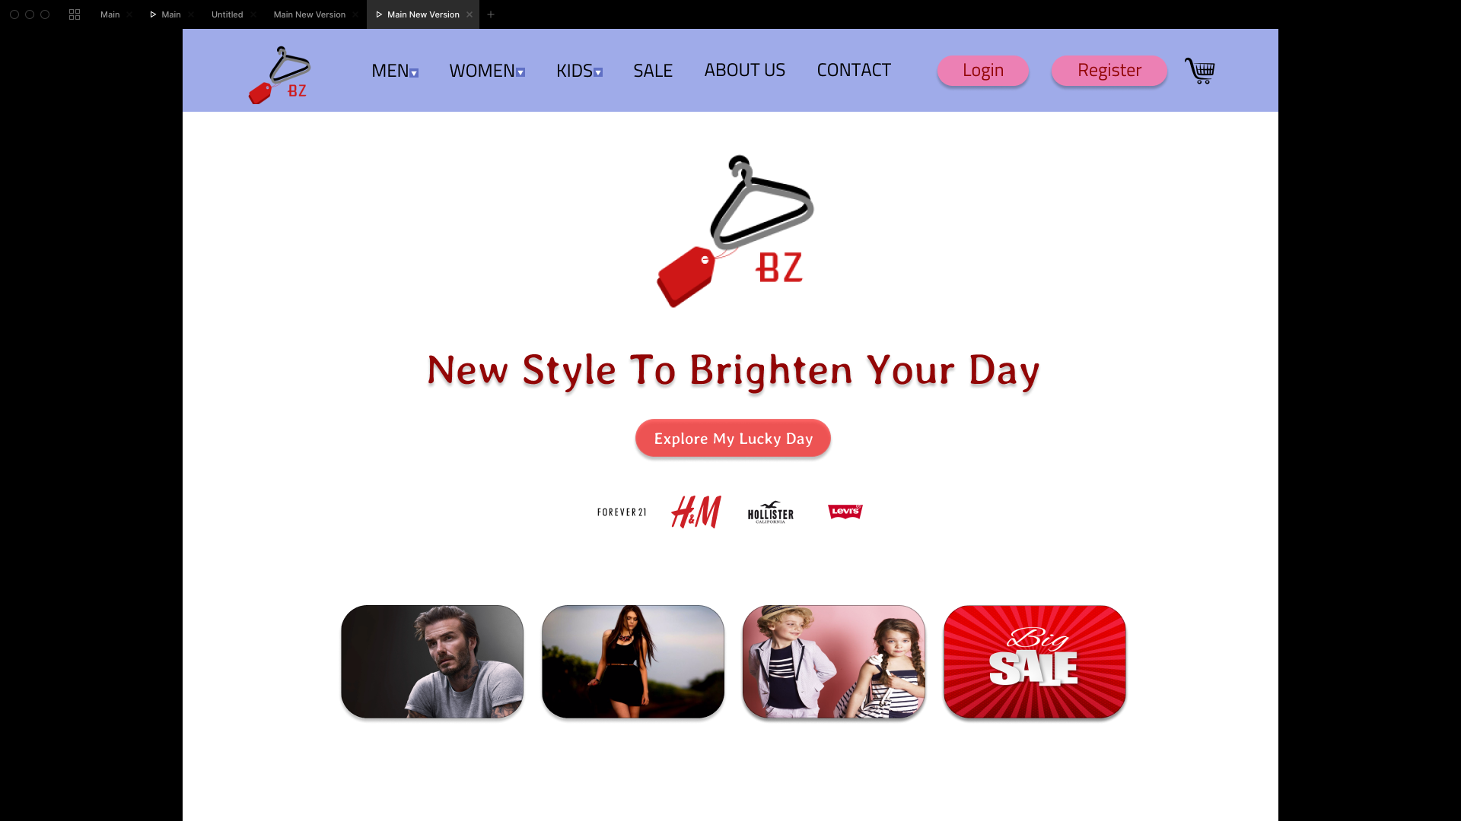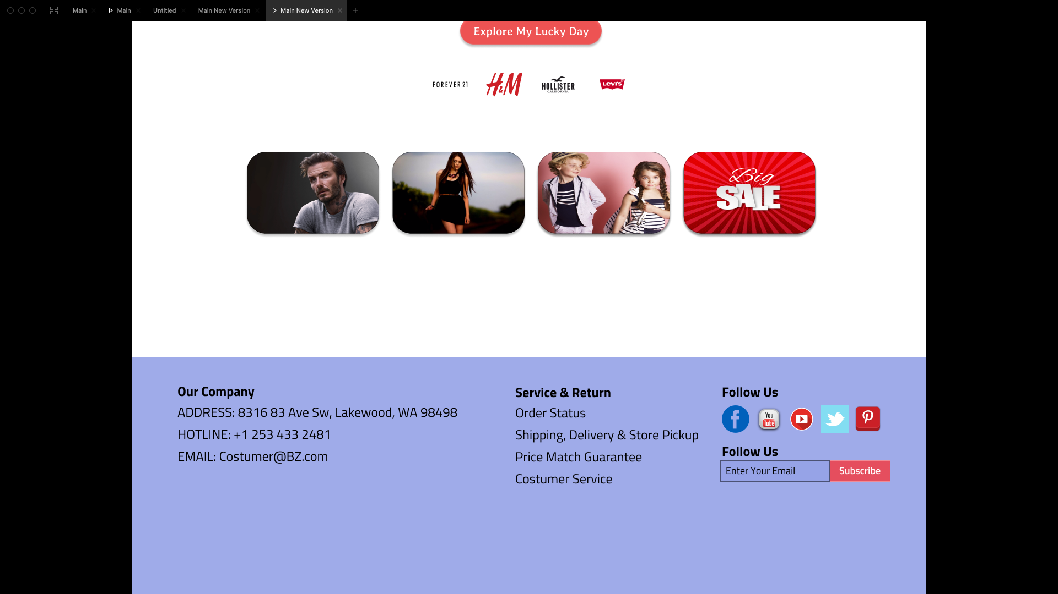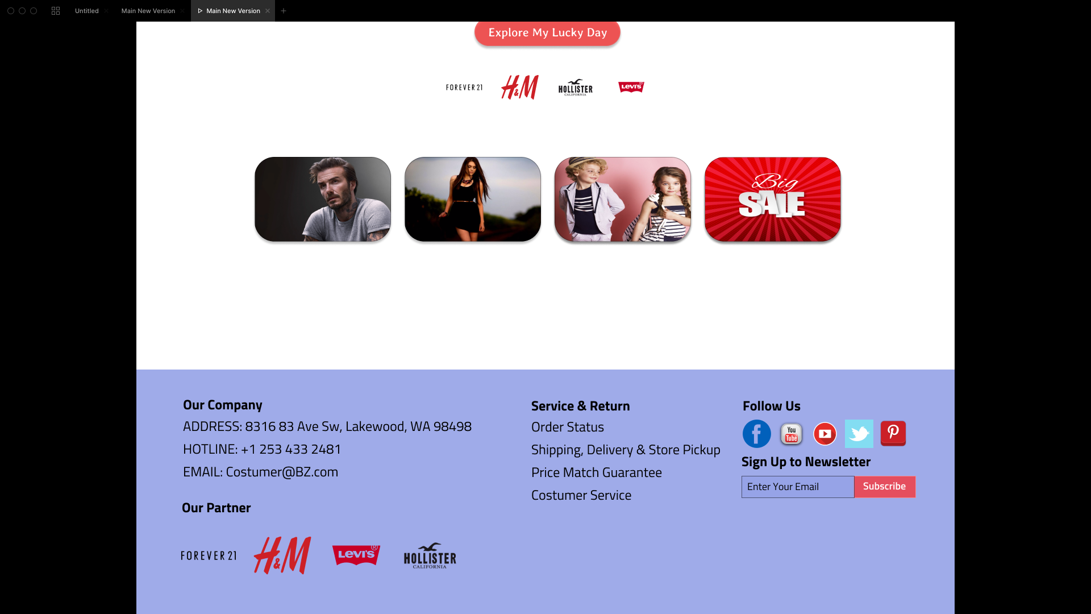

From the look of it there are many changes and promises that this going to the right direction. But when i see it more and I do more research by visiting other clothing website. I conclude my content is complete trash. The card that I was thinking to make it look good is complete waste of time, even the press button that say explore my lucky day is becoming more and more useless. Therefore this is a bad design content. The login and register pink color not work at all it is seems to look like to make people think hey ladies lets come to this sex dent sort of feeling. So I need to get rid of it completely.

Third Design

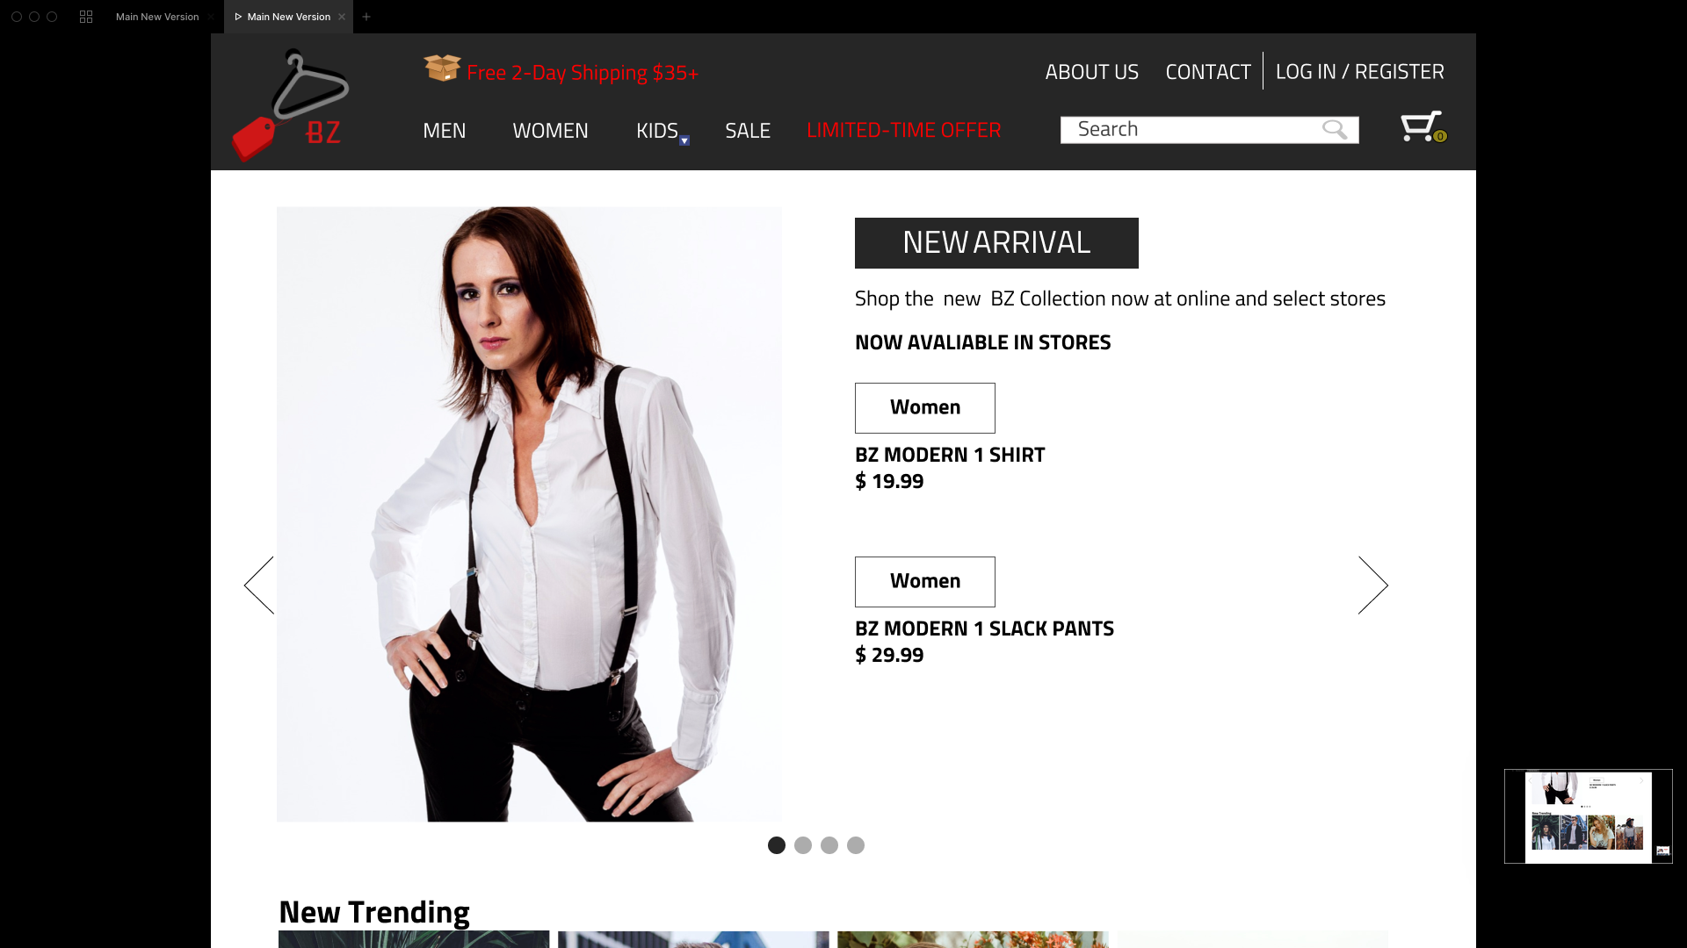

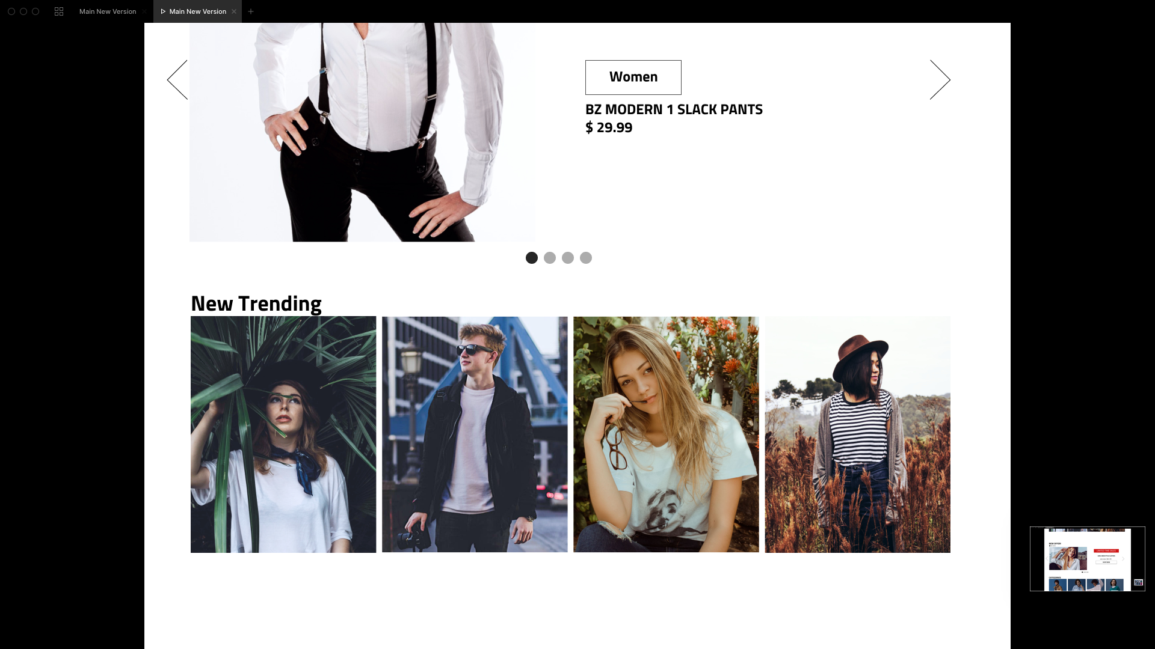

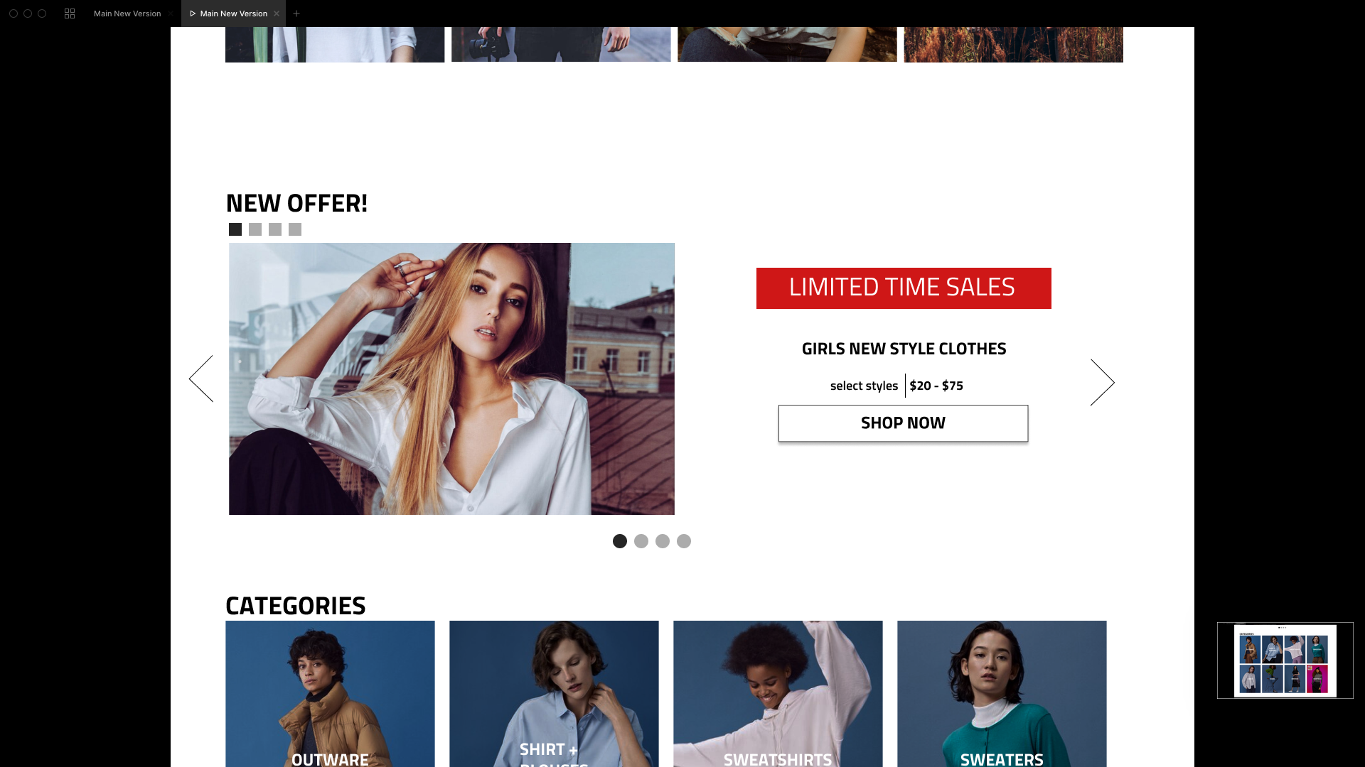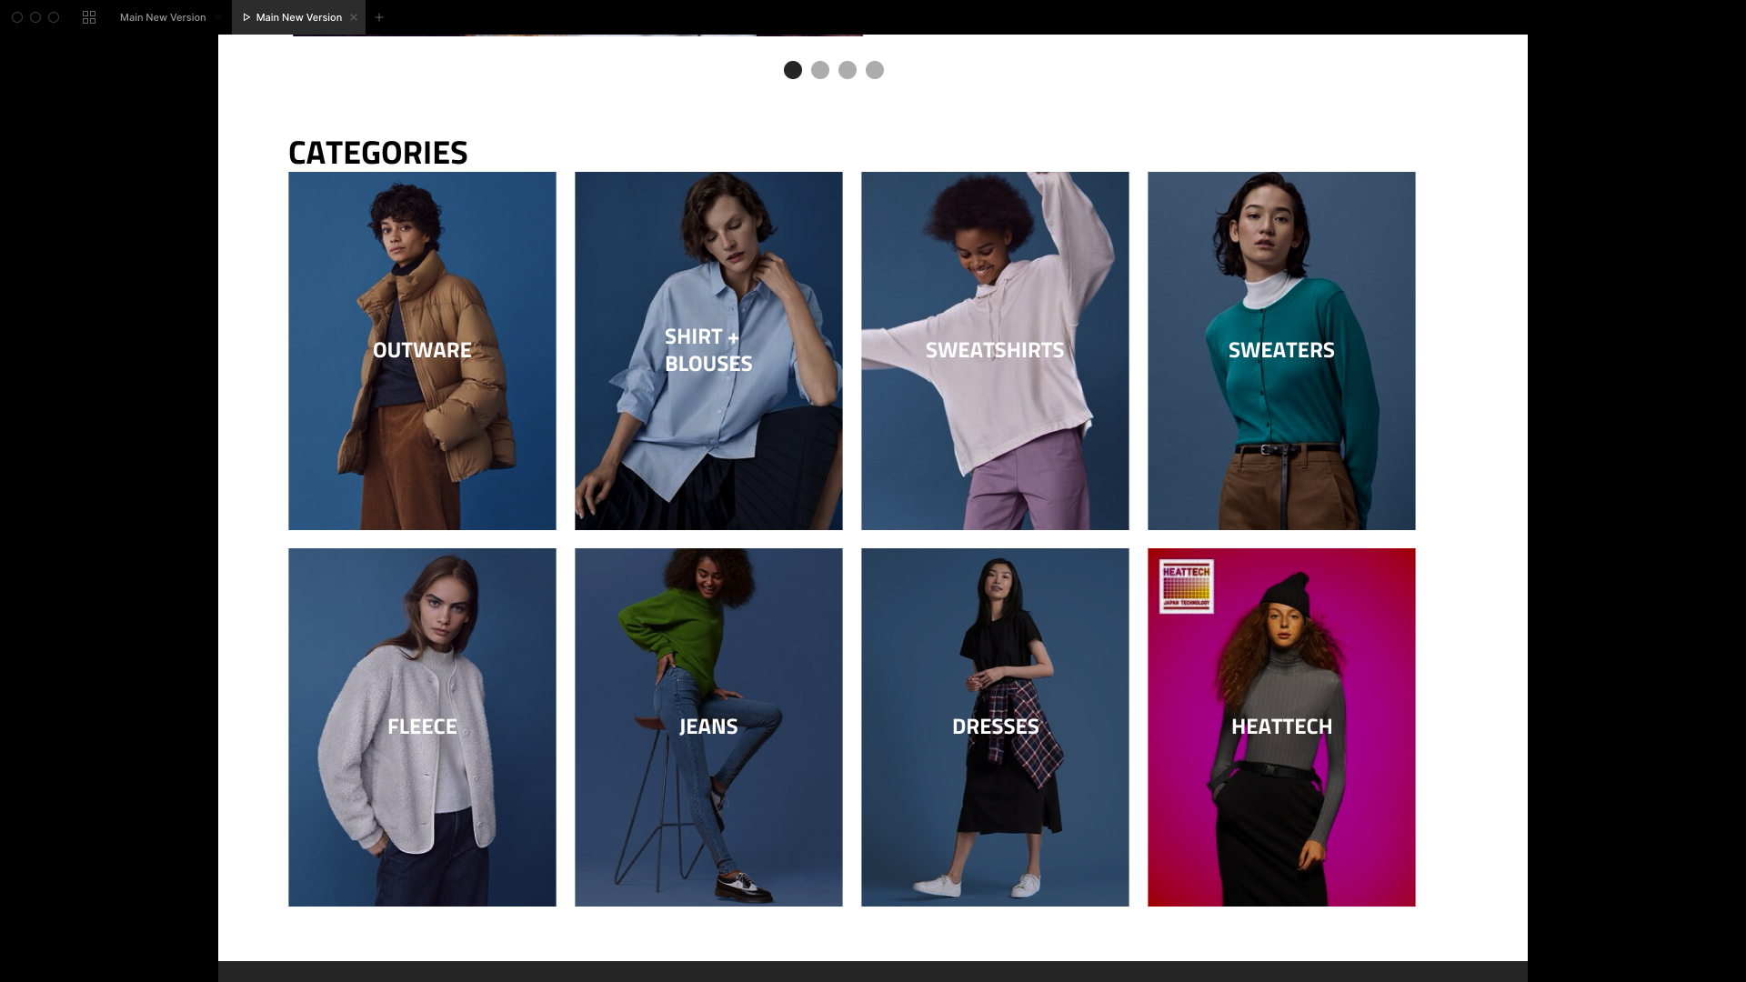

The third design Idea that i come out with taking much more promising intake. This is completely saying that I get rid of the old design and let try to rethink entire process. So I am listing what make a good website.

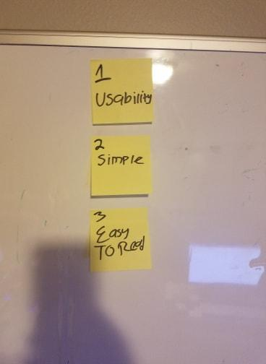

I came out with this List

1. Usability

I need to think that the user is like my mom who is 63 and she is not really good at over complicated technology. If she be able to use it then the product is usable to everyone especially to this generation that basically born with technology in their cribs.

1. Simple

Simple Simple Simple and Simple. This one single word is the big blockage of my ability because I think that this is simple but simple by me not mean simple by everyone.

I need to think to this idea of everyone is like my mom, if i make things too complicated no one would use it. “Dont make people think” so make it very simple.

1. Easy To Read

First of all what make people readable easy. If the background black make it white. If the background white make it black. This is sound simple enough but i am clealy not doing this in my first and second design.

In second design I making sure about content I make sure clearly that in the home page they should have four things that people like to see. Base on my field research from the internet and or from talking to potential buyer/ user of the website, I conclude they want to see

1. Whats on sale
2. Whats new
3. Whats trending right now
4. And lastly they like to shop by categories

This is why I came out with my third design I make sure it is usable, simple and easy to read. While I am making sure to include the elements that people want to see.